VERSION NO. 00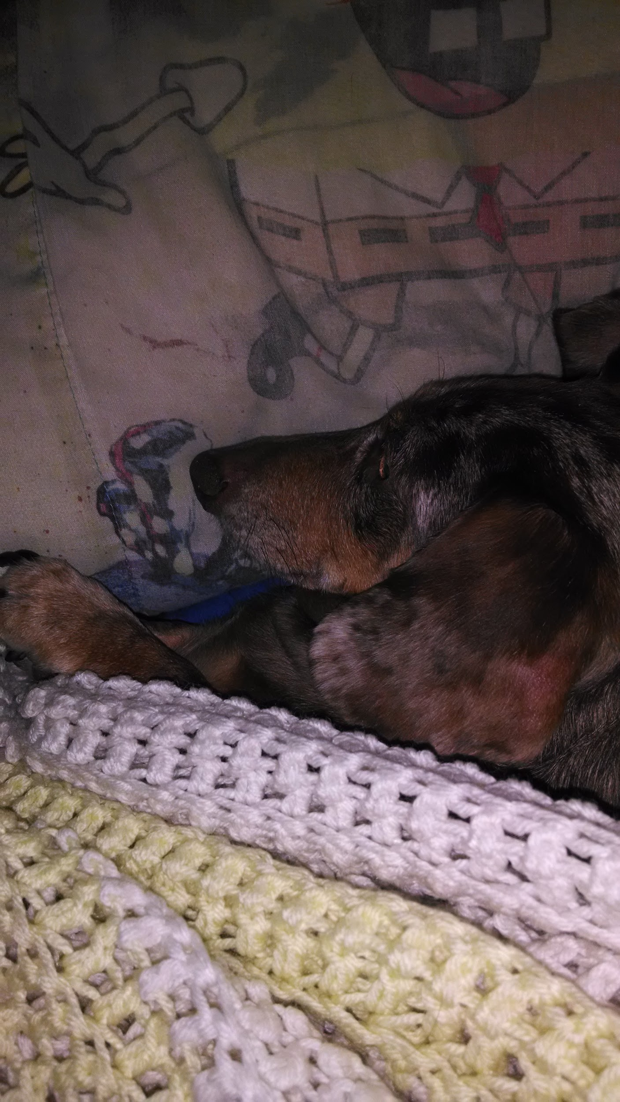

Game Design

Game Document

Darkest Night

Sleeping Dog Enterprise

Ryan Sobczak

All Work Copyright © 2017

[www.ryansobczak.wordpress.com](http://www.ryansobczak.wordpress.com)

February 13, 2017



Sleeping Dog Enterprise

Darkest Night

[www.ryansobczak.wordpress.com](http://www.ryansobczak.wordpress.com) | Feburary 13, 2017

INDEX

------------------------------------

Version History |p.02

Game Overview |p.03

Game Design Goals |p.03

Game Details |p.04

Game Story |p.

Inspiration |p.05

The Game World |p.

The Physical World |p.

Game Characters |p.

Victor |p.

Unspeakables |p.

User Interface |p.

Attribute or Ability System |p.

Level Up System |p.

Musical Scores & Sound Effects |p.

Musical Scores |p.

Sound Effects |p.

Game Blueprint |p.08

Godforsaken City |p.



Sleeping Dog Enterprise

Darkest Night

[www.ryansobczak.wordpress.com](http://www.ryansobczak.wordpress.com) | Feburary 13, 2017

VERSION HISTORY

VERSION NO. 00

This is the first revision of the Design Document. There are no changes from the previous version.



Sleeping Dog Enterprise

Darkest Night

[www.ryansobczak.wordpress.com](http://www.ryansobczak.wordpress.com) | Feburary 13, 2017

GAME OVERVIEW

This game is a top down strategy survival game. The player has to set up barricades during the day. At night is when the monsters come out and try to attack the player. The player has to survive until the morning. The monsters will be using dynamic pathfinding to reach the player. The player can put down a couple of different barricades: one to completely stop the monster and one that takes time to break down. The player will only get a certain number of resources to set up the blockades.

This game will be made in Unreal using blueprints. It is a game engine that the programmer has never used. Although once the programmer learns it, he can easily get the work done. This game will also be ported to the xbox 360.

Game Design Goals

Unreal Engine - Learning how to use Unreal Engine because I have never used but wanted to learn. I wanted to learn it because it is a very powerful engine that is used in the video game industry.

Dynamic Pathfinding - Having the enemy be able to always find the best way to reach the player at runtime. This is the centerpiece of the whole game. The AI has to outsmart the player while the player is trying to outsmart the AI

Porting to Console - Learning how to port a game to the xBox 360. This game is being made in Console Programming. This shouldn’t be difficult using Unreal.



Sleeping Dog Enterprise

Darkest Night

[www.ryansobczak.wordpress.com](http://www.ryansobczak.wordpress.com) | Feburary 13, 2017

Game Details

The Purpose of the Game?

The Purpose of this game is to make a game that is made in Unreal Engine. The core concept features dynamic pathfinding. The game will be made for PC and ported to xBox 360.

What Makes this Game Different from Competing Games?

This game will be different from other competing games because I am making this game for myself. So I am gonna work to make it what I want.

What is the Story Setting?

The Story is about a man named Victor. He lives in an abandoned city. During the daytime the city is peaceful. At night the monsters come out and attack him.

What/Who Will the Player Control?

The player controls the main character, Victor. It is a top down view. The player will be able to control where the character can go and the objects that the character can place.

What is the Main Objective?

The main objective is to survive. This is achieved by surviving the night. During the day the player sets up barricades to block the monsters. At night the monsters attack the player by dynamically pathfinding to him/her.



Sleeping Dog Enterprise

Darkest Night

[www.ryansobczak.wordpress.com](http://www.ryansobczak.wordpress.com) | Feburary 13, 2017

INSPIRATION

The city art style is inspired by the Brazilian slums. This is because the city has a crowded but abandoned feel. The slums match both criteria, they are many houses in a small space. But there are many alleys that can be used by the enemies to travel. In the game the slums are abandoned because they inhabitants were the first ones to die to the monsters.



<https://www.trip.me/blog/wp-content/uploads/2014/07/favela-scape.jpg>



Sleeping Dog Enterprise

Darkest Night

[www.ryansobczak.wordpress.com](http://www.ryansobczak.wordpress.com) | Feburary 13, 2017

*7 Days to Die* is a survival horde crafting game. This game is where I got my inspiration for the monsters attacking at night. In *7 Days* you are a survivor in a zombie infested world. There are zombies at all times but they become aggressive at night. In my game the player has to set up defenses during the day because at night the monsters attack the player.

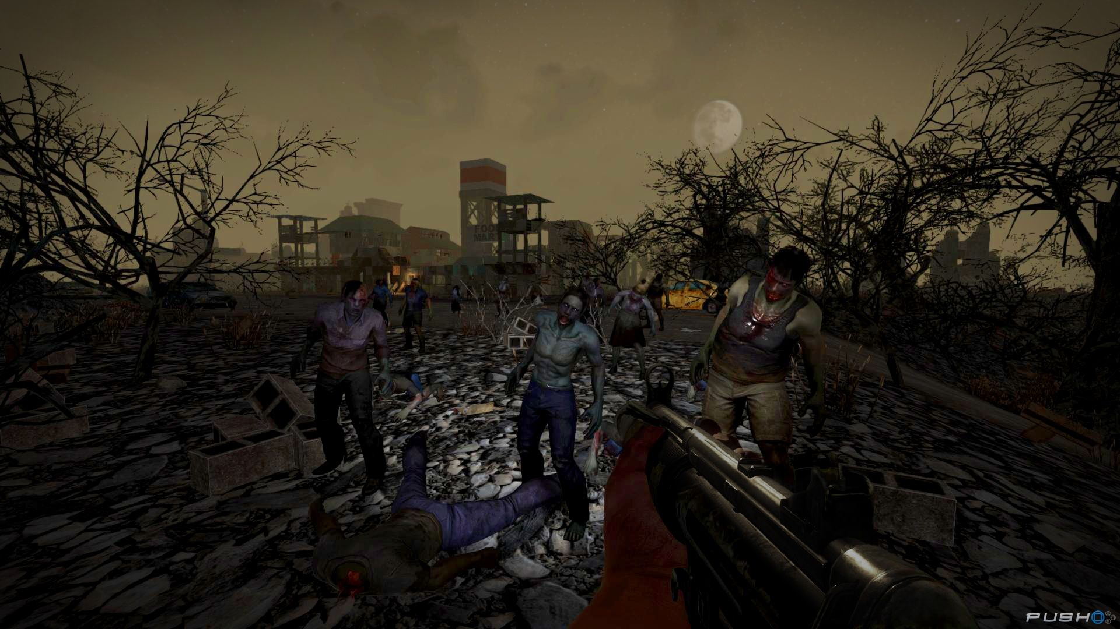

<http://images.pushsquare.com/screenshots/77870/large.jpg>



Sleeping Dog Enterprise

Darkest Night

[www.ryansobczak.wordpress.com](http://www.ryansobczak.wordpress.com) | Feburary 13, 2017

The vehicle AI, in *Saints Row 4*, inspired me to want to make a game that used dynamic pathfinding. In this game the AI tries to follow the rules of the road. But they quickly change their direction and speed when the player starts shooting at them.

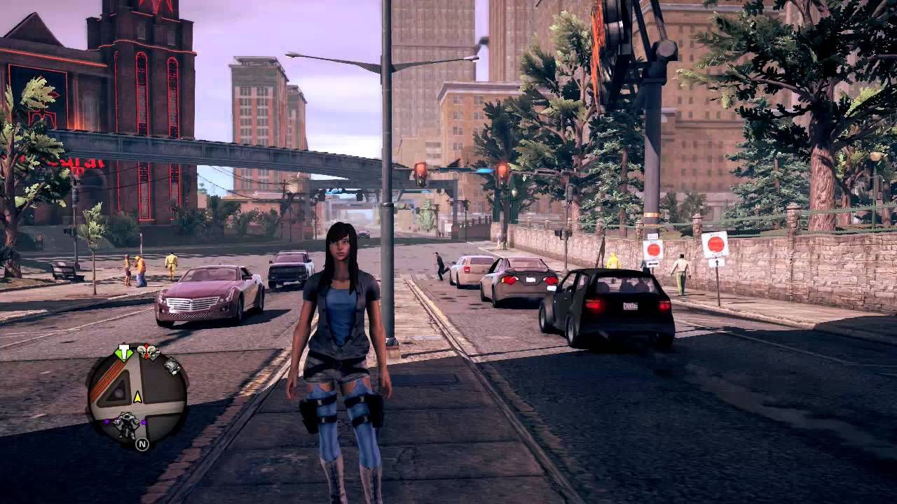

<https://i.ytimg.com/vi/IpbNQRgebpo/maxresdefault.jpg>



Sleeping Dog Enterprise

Darkest Night

[www.ryansobczak.wordpress.com](http://www.ryansobczak.wordpress.com) | Feburary 13, 2017

GAME BLUEPRINTS

This game starts in the day. During this time period the player has to set up his/her defenses. The player will only be given a certain number of resources to set up the barricades. When night happens, the player can still set up barricades but every barrier will cost twice as much to set up. Once night begins the monsters will attack and begin to travel to the player using dynamic pathfinding. If any monsters reach the player. The player dies and respawns at the beginning of that day. If the player survives the night, he/she will be given a reward of resources.

The monsters spawn will be pseudo random. They can spawn at multiple points on the map, around the edges of the map. Their number will also depend on the day. The more days the player has played the game, the more enemies will spawn. It won’t be a 1-1 ratio. That would be too much to handle for the player. The actual ratio will have to be tested to see what feels the best.



Sleeping Dog Enterprise

Darkest Night

[www.ryansobczak.wordpress.com](http://www.ryansobczak.wordpress.com) | Feburary 13, 2017

|  |  |  |
| --- | --- | --- |
| Question | Answer | Reasoning |
| How many Lives? | 1 live, but if the player dies, he/she will respawn at the beginning of that day | 1 live seems like the best option to have for a strategy survival game. |
| How many Stages? | 1 world, but in that world, the player will have multiple days to survive | This game works better as 1 open world than multiple stages. |
| How many Enemies? | Depends on the day. As the player advances more enemies will spawn and try to attack the player | This is to make the value of playing multiple days worth it. Otherwise the player would become bored quickly. |
| When to Level up? At which Stage? | There is no leveling up in this game, At the moment. | Leveling up will be a stretch goal. The level ups would include better and more barricades to set up. |
| What powers/Weapons? | There's no powers or weapons, just barricades to set up to protect yourself. | This is a game to see who is smarter the AI or the player, adding weapons might affect this. |